7.2 Editors - 3D View - Tool Shelf
3D View editor 2
Active Tool 2
Tool Settings 2
Mode dependant content 2
Tooltips 2
Tool groups 3
Resizing the tool shelf 3
Switching Tools 3
Cycling through Tools in groups 4

3D View editor
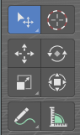
Some editors have a tool shelf at the left. Here you can find and use various tools.

Active Tool
In the tool shelf there can just be one active tool in the tool shelf. An activated tool stays active as long as you don't change it. To deactivate the current tool you have to choose another tool. One of the select tools for example.

Tool Settings
When you activate a tool in the tool shelf then you will also reveal its tool settings. There are two locations where you can find the tool settings. In the header, and in the sidebar in the Tool tab. It's your choice with which panel you want to work.
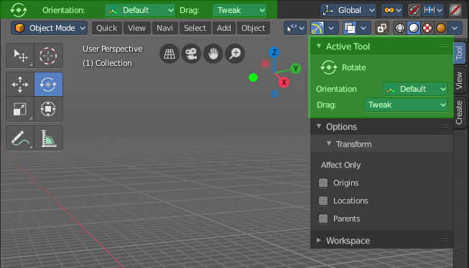

Mode dependant content

The content of the tool shelf is changing dependand of the mode that you are in, and dependant of the object type. A mesh object in edit mode has another set of tools than a metaball. But there are some tools that are available in all modes. 3D Cursor, Select tools and Transform tools.

Tooltips

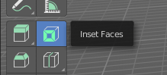
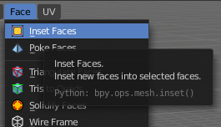
The new tool system works here and there different from the old tool system. It is one gigantic hack on top of the old tool system. Already the tooltips are different. It misses the Python strings. And some tools misses a proper description. The tooltips are separated from the operators.

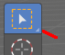
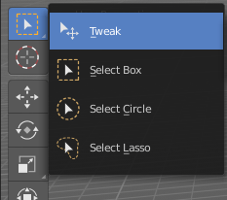
Tool groups
Some icons have a white small triangle down right. This indicates that this icon is part of a tool group. This group can be revealed by holding down the mouse until the popup reveals the hidden tools. You can then choose the needed tool in this group. And it will become the one that gets displayed.

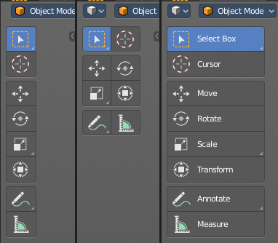
Resizing the tool shelf
The tool shelf can be resized by dragging the border of it in and out.
You have the choice between one, two and three icon rows. And text and icon buttons.
Currently the default starts with two rows.

Switching Tools
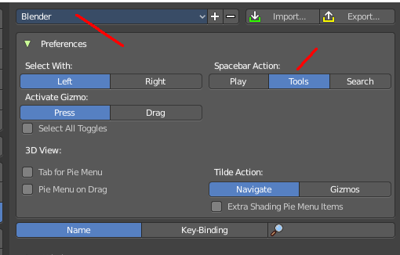
The Blender keymap provides a way to call the tools from the tool shelf under the mouse in a popup menu. And with hotkeys. Even when they don't have a hotkey assigned in the toolbar yet.
Keyboard tool switching is not enabled by default. You need to set the key-map preference Spacebar Action to Tools. And when you press spacebar, then you will see the tool shelf content under the mouse. But with an hotkey assigned. And then you can use this hotkey in combination with the spacebar to activate the tool

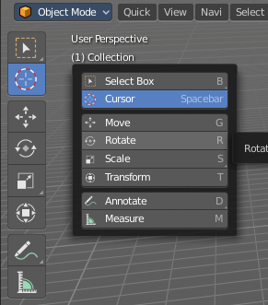
Spacebar-T for Transform, Spacebar-D for Annotate, Spacebar-M for measure, and so on.

The accelerator keys are displayed in the tooltips of the tools in the tool shelf. The hotkeys are hardcoded. And are NOT the hotkeys for the tools in the tool shelf. But just the hotkeys in conjunction with the spacebar menu!

Attention, this is not implemented in the Bforartists keymap yet. This feature is just available in the Blender keymap!

Cycling through Tools in groups
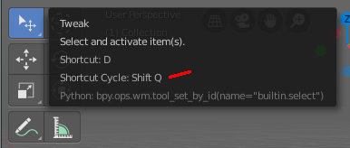
You can assign a hotkey to a group of tools, and then activate Cycle in the keymap manager. This allows you to cycle through the tools in this group with the hotkey.
This is for example done with the Select tool group. The hotkey to cycle through the tools in the group shows in the tool tip.

